**Detecting NEMO (dNEMO) Guide (gUIDE)**

Last updated January 9, 2019.

Contents

1. License
2. Requirements
3. Installation and Startup
4. User Interface
5. Loading Images into dNEMO
6. Display Panel
7. Spot Detection Settings
8. Creating Keyframe Objects
9. Segmenting Cells Using Drawing Tool
10. Modifying and Deleting Keyframe Objects
11. Manual Removal of Erroneous Signals
12. The Inspector Tool
13. Output Files
14. Reloading Results into dNEMO
15. Guided Example: smFISH
16. Guided Example: EGFP-NEMO
17. References

(Note: Highlighted sections indicates section text may not be up-to-date with the latest dNEMO version).

1. License

This program is free software: you can redistribute it and/or modify it under the terms of the GNU General Public License as published by the Free Software Foundation, either version 3 of the License, or (at your option) any later version.

This program is distributed in the hope that it will be useful, but WITHOUT ANY WARRANTY; without even the implied warranty of MERCHANTABILITY or FITNESS FOR A PARTICULAR PURPOSE. See the GNU General Public License for more details.

You should have received a copy of the GNU General Public License along with this program. If not, see <http://www.gnu.org/licenses/>.

2. Requirements

The program has been tested using the following operating systems:

Mac OS 10.12.6 64-bit, Windows 10 64-bit

MATLAB versions: 2017b, 2018b

MATLAB toolboxes required to run every component of the packaged software:

* Image Processing Toolbox
* Signal Processing Toolbox
* Statistics and Machine Learning Toolbox

3. Installation and Startup

1. Download the latest version of the dNEMO software package from <https://github.com/recleelab>.
2. Extract all files from the downloaded zip file.
3. Open MATLAB.
4. Add the ‘dNEMO’ directory to the current path in MATLAB, either by copying the unzipped folder to the current path and adding the folder to the current path or navigating to the unzipped folder in the MATLAB folder window and adding the folder to the current path.
5. To start dNEMO, type the following into the MATLAB command window:

>>> RUN_ME

This will open the main dNEMO user interface.

4. User Interface

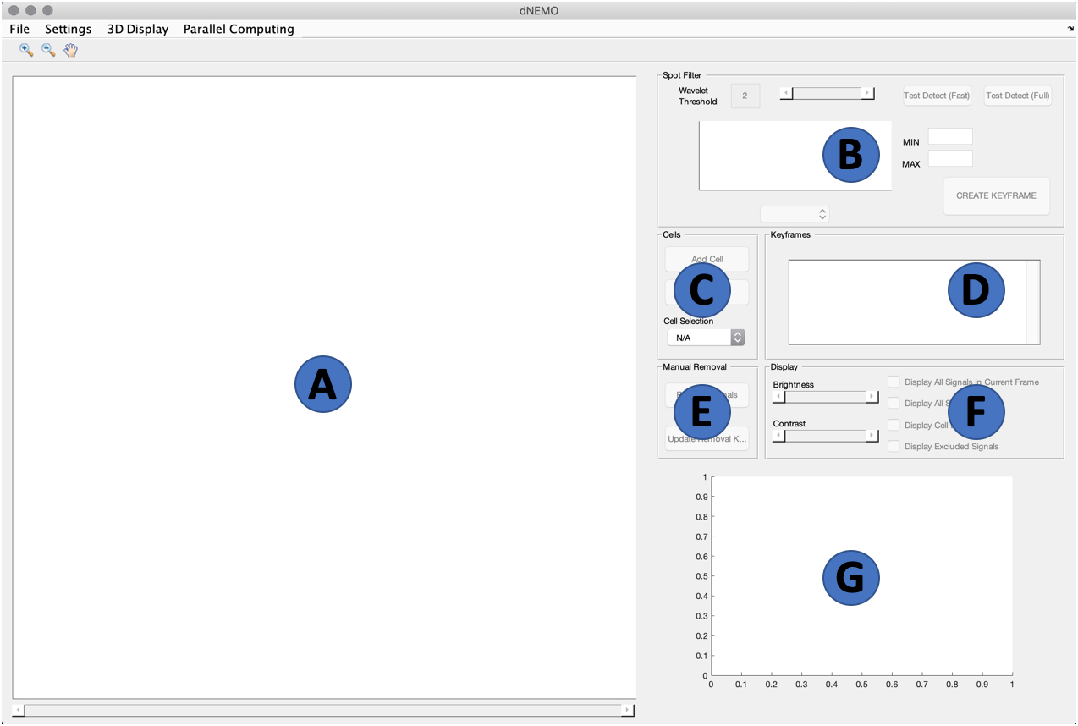

Each of the 5 main panels, ‘Spot Filter’, ‘Cells’, ‘Keyframes’, ‘Display’, and ‘Manual Removal’ will be explained in detail in later sections. A brief overview of each of dNEMO’s interface components follows:

1. **Image axis:** main axis which displays the image, spots identified within the image, interactions for cell segmentation and selection of individual spots.
2. **Spot Filter panel:** the main panel for defining the parameters of spot detection and assigning new keyframes for feature selection. The specific components of this panel are defined in Section 8 (Creating Keyframe Objects).
3. **Cells panel:** main panel for handling cell creation and modification. The specific components of this panel are defined in Section 9 (Segmenting Cells Using Drawing Tool).
4. **Keyframes panel:** main panel for accessing and modifying existing keyframe data. Created keyframe objects are displayed within this panel. The specific interactions and use of this panel is detailed in Section 8 (Creating Keyframe Objects) and Section 10 (Modifying and Deleting Keyframe Objects).
5. **Manual Removal panel:** main panel for manually removing spots known to be erroneous to the user. The specific components of this panel are defined in Section 11 (Manual Removal of Erroneous Signals).
6. **Display panel:** main panel for interaction with items displayed on the Image axis (A). The specific components of this panel are defined in Section 6 (Display Panel).
7. **Trajectory axis:** axis which displays single-cell trajectories of the number of objects found per cell. Trajectories will automatically appear in this axis when spot detection keyframes and cell keyframes have been created within the application.

5. Loading Images into dNEMO

To load images into dNEMO, navigate to File > Load Images. This will open an interactive file selection GUI where an image/movie can be selected. dNEMO currently supports files with .TIF(F) or .DV extensions. dNEMO does not currently support multichannel images, and will not parse multichannel images correctly. dNEMO utilizes Bio-Formats (1) for handling image input, and is packaged with the tool.

Once a compatible image file is selected, dNEMO will prompt for additional information if the image file’s metadata cannot be parsed for additional information. The user will be prompted to confirm whether the image is 2D or 3D, and how many Z-slices comprise each frame for the latter.

Once the image is present in the main axis, the ‘3D Display’ Menu can be selected to alternate between the max intensity projection and 3D stack of the current frame. When the ‘Full 3D Stack’ option is selected, an additional slider appears to the right of the image axis.

At the lower right-hand corner of the image axis a small annotation will display the current frame as T = <FRAME>. If the ‘Full 3D Stack’ option is selected, an additional annotation above the frame number will display the current z-slice as Z = <SLICE>.

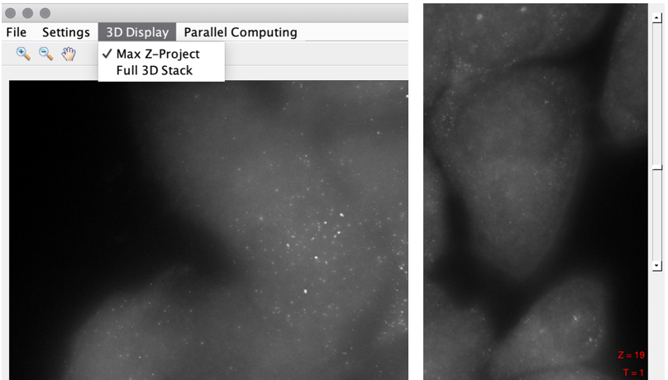

6. Display Panel

The display panel is used to quickly manipulate objects within the image axis throughout the application. All components within the display panel can be accessed during any dNEMO operation, so long as the structure the control operates on already exists (e.g., the ‘Display Cell Boundaries’ toggle will be grayed out until cells have been drawn).

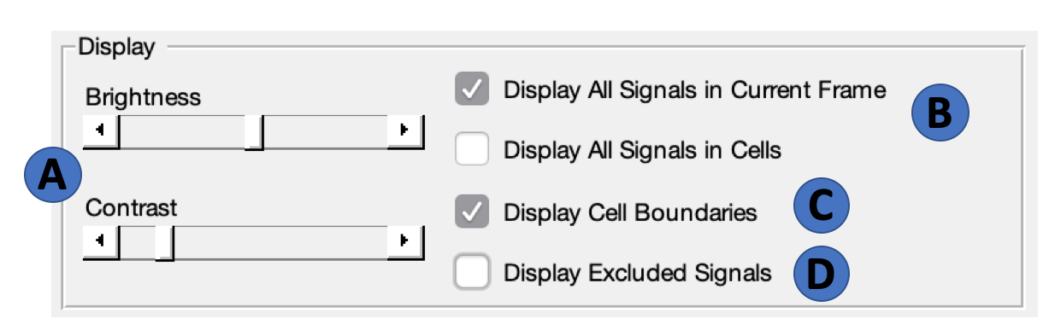

The various components of the ‘Display’ panel are as follows:

1. **Brightness & Contrast Sliders:** used to manipulate image brightness and contrast.
2. **Signal Display Toggles:** pair of toggles which alternate between displaying all signals for the current frame and all signals associated to cells. Only one of these two toggles can be active at a given time. When a specific cell is selected using the Cell Selection Dropdown (‘Cells’ panel) and the ‘Display All Signals in cells’ is on, the signals for the specific cell selected will be shown alone.
3. **Display Cell Boundaries:** toggles the boundaries of cells once drawn. When a specific cell is selected using the Cell Selection Dropdown (‘Cells’ panel), the boundary of the selected cell will be shown alone.
4. **Display Excluded Signals:** toggles signals which have been removed, either manually using the manual removal tool (‘Manual Removal’ panel) or were removed for some feature identified in a keyframe object (e.g., spots below a certain size, above a certain intensity, etc.). More details about manual object removal can be found in Section 11 (Manual Removal of Erroneous Signals). More details about selection for spot features via keyframe can be found in Section 8 (Creating Keyframe Objects).

7. Spot Detection Settings

In the upper right-hand corner of the interface there is a ‘Settings’ menu item. Clicking on ‘Settings’ will bring up a drop-down menu with the item ‘Signal Parameters.’ Click on the ‘Signal Parameters’ bar to bring up the settings input GUI. Within this GUI are several parameters which can be modified by the user. They will be used when creating any new Keyframe objects, which defines the signals captured for some range of frames within a given movie. These parameters can be changed before or during Keyframe creation, and can be modified after a Keyframe has already been created.

The parameters are as follows:

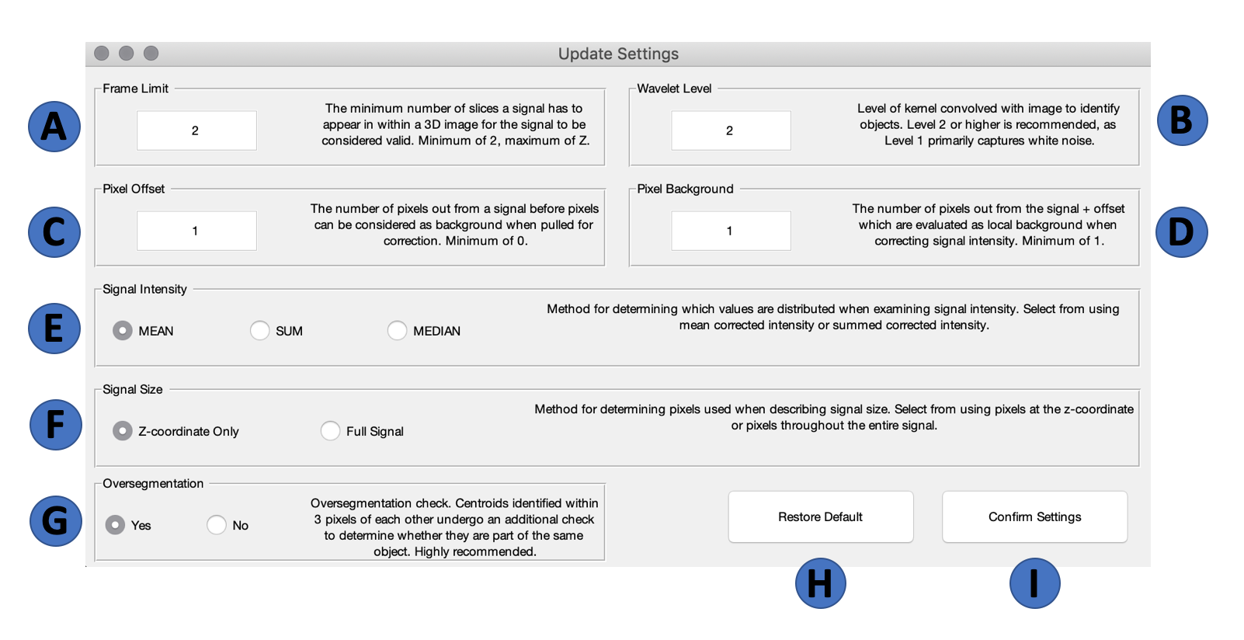

1. **Frame Limit**: The minimum number of slices a signal has to be in to be considered valid. Minimum of 1, maximum of Z. The frame limit operates as a lower bound on detected signals; signals in 3D images will initially be checked between slices to examine which ones are likely connected, and if the frame limit is set to 1 will then begin to accept any signals within each slice not connected to signals in a neighboring slice.
2. **Wavelet Level:** Level of the kernel convolved with the image to identify objects. The most delicate details of an image are caught up in the level 1 transform, largely representative of noise within the image. Level 2 has been found by us to most reliably capture diffraction-limited objects, and is recommended. Higher levels of the kernel will capture larger objects within the image, at the expense of removing smaller objects.
3. **Pixel Offset:** The number of pixels out from a signal before pixels can be considered as background when pulled for correction. This acts as a sort of buffer ring around the object. Minimum of 0.
4. **Pixel Background:** The number of pixels out from the signal + defined offset which is then collected as local background about an identified object. Minimum of 1.
5. **Signal Intensity:** Indicates the method for which signal intensities are compared against each other when determining how to more methodically remove signals known to be erroneous by the user. Available measurements are average, integrated, and median signal intensity, corrected for local background.
6. **Signal Size:** Indicates the method for which signal sizes are compared against each other when determining how to more methodically remove signals known to be erroneous by the user. Available measurements are either at the identified z-coordinate for a given signal or the entirety of the pixels comprising a signal.
7. **Oversegmentation:** Binary check which determines whether an oversegmentation check is performed on identified signals in a given image. Centroids identified within 3 pixels of each other undergo an additional check to determine whether they are part of the same object. While this does increase runtime, it is highly recommended.
8. **Default Button:** Resets current fields to their default values when the program starts up, which are shown in the image above.
9. **Confirm Settings Button:** Applies changes to the detection parameters. If there is no active keyframe creation happening, the parameters will be saved for when a keyframe will next be created.

8. Creating Keyframe Objects

Creation of keyframe objects is done through several panels, but the main detection and feature property keyframes are handled in the ‘Spot Filter’ panel. The components of the ‘Spot Filter’ panel are listed here:

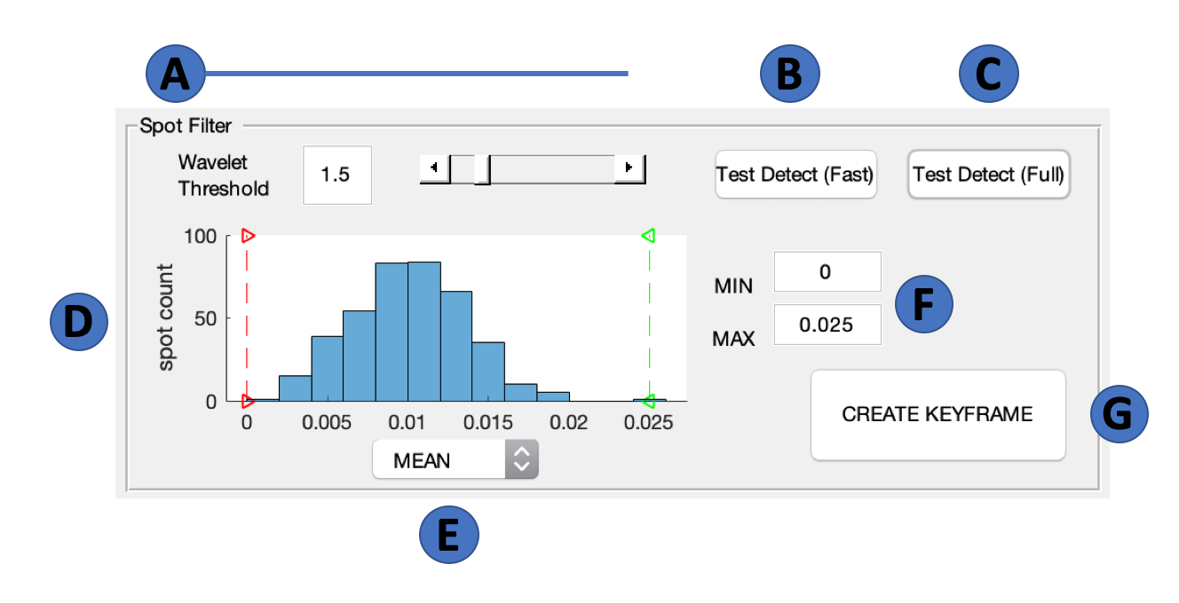

1. **Wavelet Threshold:** The primary means of control over thresholding the wavelet transform, this value represents the threshold separating what is to be considered as foreground and background in the wavelet map. The higher the value, the fewer spots will be detected; the lower the value, the more spots will be detected. The slider to the right of the edit box corresponds to this threshold.
2. **Test Detect (Fast) Button:** Button which performs wavelet transform on the currently displayed image using the indicated threshold and existing detection settings (see Section 7). This button will perform the transform without checking for oversegmented objects, meaning it will be faster than the ‘Test Detect (Full)’ operation.
3. **Test Detect (Full) Button:** Button which performs wavelet transform on the currently displayed image using the indicated threshold and existing detection settings (see Section 7). This button will perform the transform and perform an additional check for oversegmentation of detected objects, meaning it will be slower than the ‘Test Detect (Fast)’ operation.
4. **Histogram Axis:** Clickable axis which allows user to see which objects have indicated properties. The current feature being displayed on the x-axis is displayed in the Feature Dropdown (E), Whenever the histogram is interacted with, spots with features that fall outside the bars are indicated as such on the image axis in red (see Section 4). This axis can be interacted with at any time to examine shifts in distribution of spots’ features for a given image.
5. **Feature Dropdown:** Dropdown menu which allows user to select which feature to display along the x-axis of the Histogram Axis (D).
6. **Histogram Min / Max:** Display boxes which indicate the current values of the red and green bars within the Histogram Axis (D). Clicking within these windows and typing new values for the histogram min and max will be reflected in the Histogram Axis (D).
7. **Create Keyframe Button:** Button clicked on to create a new keyframe. Keyframe button will check feature selection bounds present in the histogram axis and assign a new keyframe. If there has been a change in the spot detection settings or wavelet threshold, or if no spot detection keyframe objects yet exist, the wavelet transform will be applied to the relevant movie frames.

9. Cell Segmentation

The software dNEMO provides a manual segmentation tool for defining individual cells within images over time. This process can be started separately from spot detection for a given movie. The steps to this process are as follows:

1. Click on the ‘Add Cell’ button within the ‘Cells’ panel.

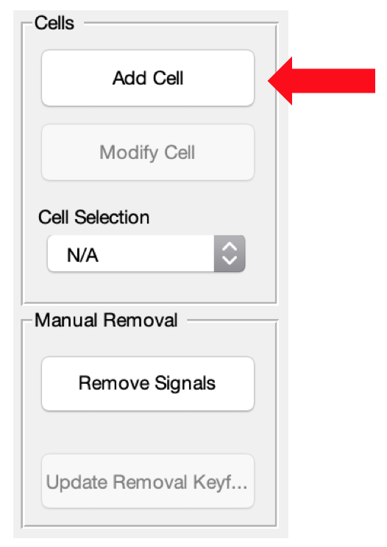

1. Hover over the image axis. The pointer should now look like a crosshair over the axis. Click on the axis at the edge of some cell within the image to begin the process of overlaying a polygon over the image.
2. Continue clicking along the edge of the observed cell to define the region to be considered as an individual cell. Return to the initial point set on the axis and click on it to complete the cell, or double click on the image axis to have the polygon automatically close the gap between the last point placed and the initial point.

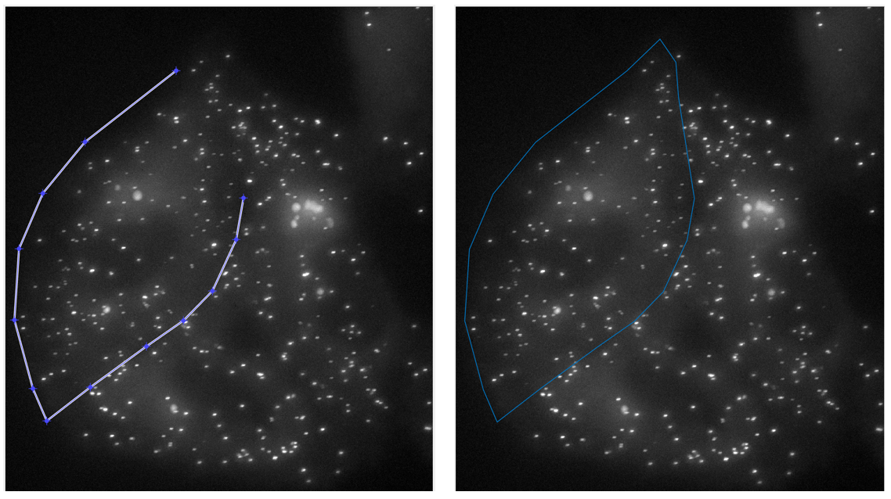

1. Completing a segmentation creates a new cell object. The cell’s shape is keyframed like all other parameters / settings. To update this keyframe, and thus the cell’s shape / movement over time, increment through the movie and modify the cell’s shape by clicking the ‘Modify Cell’ button on different frames.

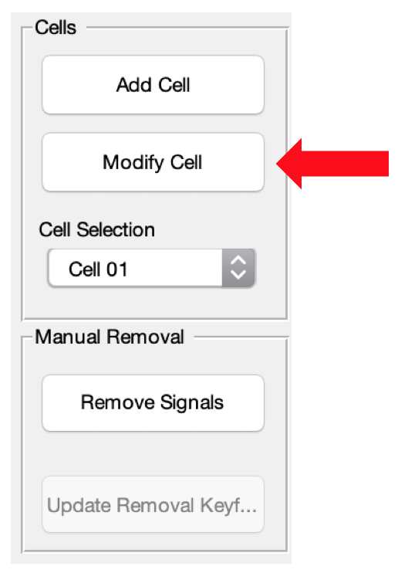

The ‘Modify Cell’ button is enabled when an individual cell is selected, either through clicking on the cell in the keyframing map or selecting the cell in the ‘Cell Selection Dropdown’ within the ‘Cells’ panel.

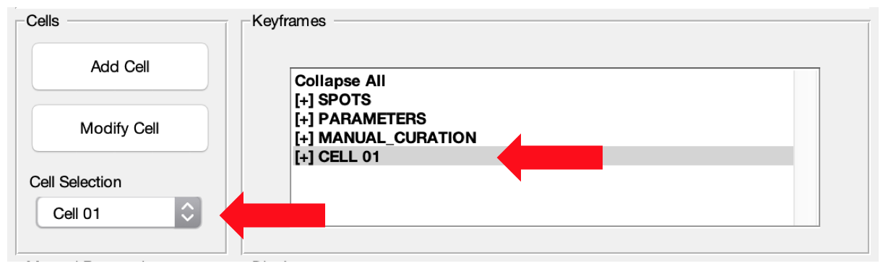

Modification can be canceled at any time by clicking the ‘Cancel Cell Modify’ button (previously ‘Add Cell’), and saving any modifications can be done by clicking the ‘Update Cell Keyframe’ button (previously ‘Modify Cell’).

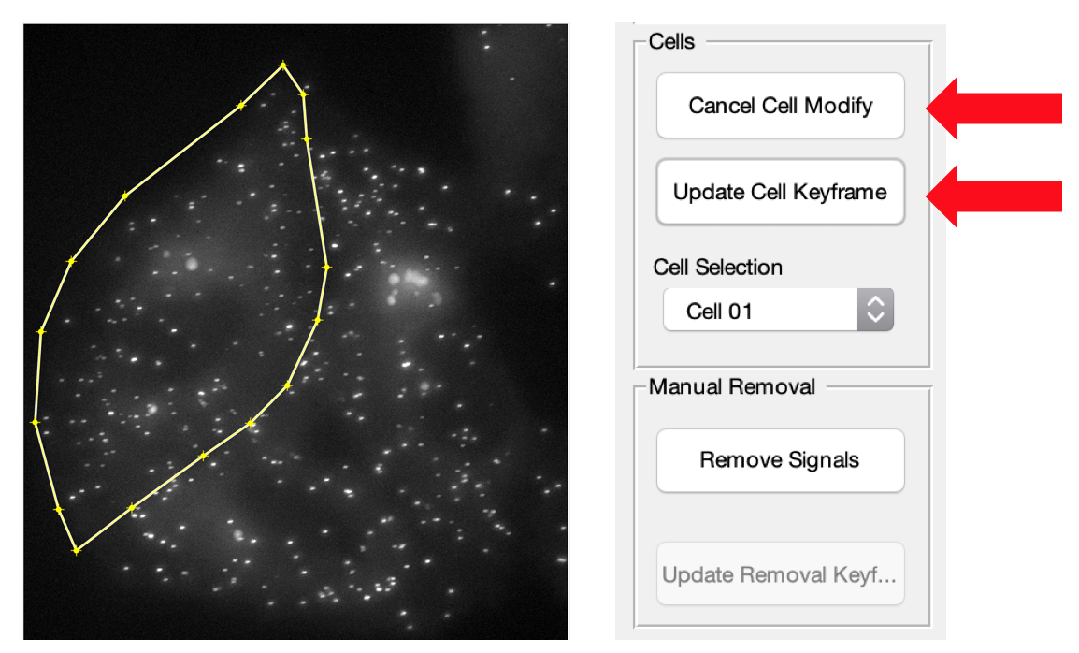

1. To delete cell keyframes, navigate to the keyframing map and right click to delete cell keyframes, as you would any other keyframe. Right clicking on the cell header gives the option to delete the cell altogether. Additionally, modification of cells and their keyframes can also be accessed by right clicking on the keyframing map.

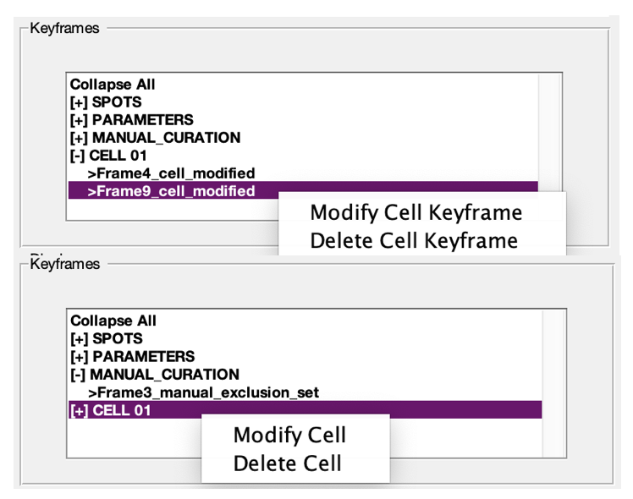

1. Any changes made to cell keyframes will be reflected in the polygon shape displayed on the image axis and in the cellular trajectories displayed in the lower right corner of the dNEMO interface.

10. Modifying and Deleting Keyframe Objects

Any parameter or setting identified within the ‘Keyframes’ panel is an item that can be modified or deleted. Any setting which has been keyframed is applied from the frame at which the setting was applied until it reaches another keyframe for that same setting. Deleting a keyframe removes that applied setting from the time-series, and any previously defined keyframes will be applied to the frames which no longer have a keyframe associated with them.

The ‘SPOTS’ subheading in the ‘Keyframes’ panel is critical for all other keyframes apart from CELLs. Additional keyframes are added by readjusting the wavelet settings in the ‘Spot Filter’ panel for a given frame and creating a new keyframe by clicking ‘CREATE KEYFRAME’ button. The keyframe will be applied from the current frame onwards. Deletion of a property is done by right clicking on the given property in the Keyframes panel and selecting ‘Delete Keyframe’.

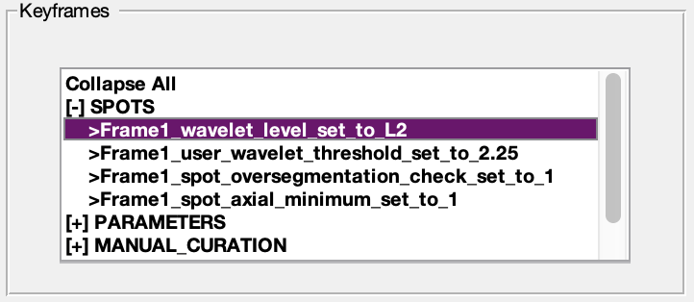

CAUTION. The SPOTS keyframes always need some baseline for the ‘PARAMETERS’ and ‘MANUAL_CURATION’ keyframes to exist – deleting all SPOTS keyframes will remove current detection data. A warning will pop up before these events occur.

PARAMETERS and MANUAL_CURATION keyframes can be modified/removed at will.

PARAMETERS keyframes are added either by manipulating the histogram axis in the ‘Spot Filter’ panel and clicking ‘CREATE KEYFRAME’ for a new minimum/maximum feature, or opening the ‘Spot Inspector’ tool and setting a new background/offset pixel radius to apply to spots (see Section 12). Right-clicking on any parameter will dropdown options to either delete or modify. Clicking modify will navigate to the frame at which that parameter was set, and turn on the respective tool for the given parameter (either the histogram axis or the spot inspector tool).

Deleting the parameter will remove the parameter’s keyframe from the ‘Keyframes’ panel and remove the setting from the current detection. Any keyframes defined before the deleted keyframe for the same parameter will be applied to subsequent frames.

MANUAL_CURATION keyframes define the set of any manually removed objects defined by the user. Selecting to ‘Modify’ or ‘Delete’ them will return the removed objects to the full set of detected objects. These keyframes operate on a per-frame basis, as they define the set of removed spots for that frame (see Section 11).

11. Manual Removal of Erroneous Signals

Objects can be removed from the currently displayed set by manually selecting them or clicking within the image and dragging the cursor to create a box which removes any signals within it from the current keyframe. The process can be initiated from the ‘Remove Signals’ button in the ‘Manual Removal’ panel.

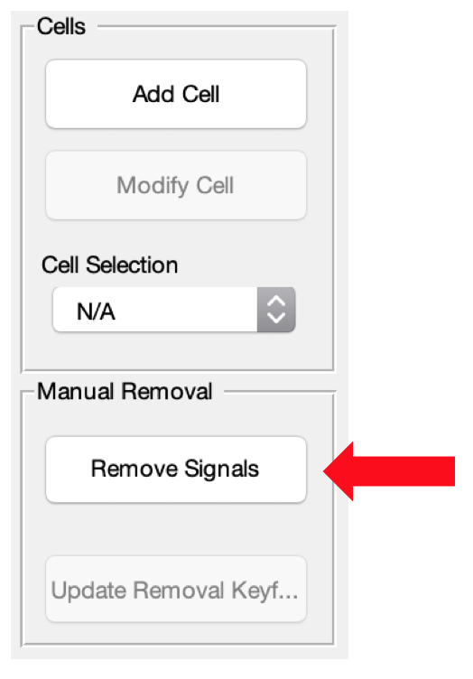

At this point, other operations like creating/modifying/deleting keyframes and cells are temporarily disabled until the ‘Remove Signals’ button is clicked again. Once the removal process is started, clicking on objects within the main screen will mark them for removal from the current keyframe. Removed objects can be returned by clicking on that same object again.

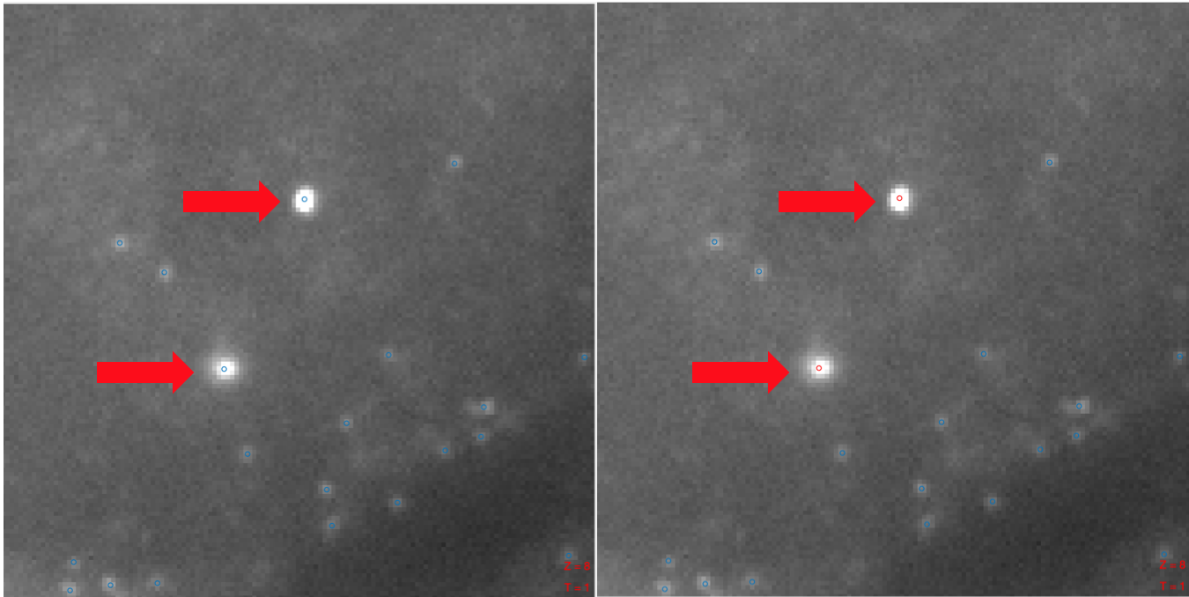

Larger regions with objects erroneously caught up in detection can be selected by clicking down on the image and dragging across the image to create a box which removes all objects currently within it. As with clicking on a spot again to return it to the keyframe, dragging a box over previously removed objects will return them to the keyframe’s set of objects for the current frame.

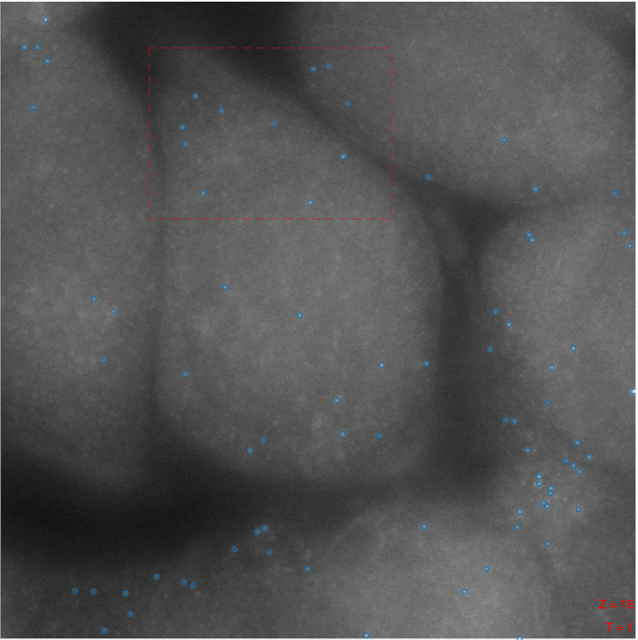

To save manually removed objects for the current frame, click on the ‘Update Removal Keyframe’ button in the ‘Manual Removal’ panel. Objects removed will not be saved until that button is clicked. Sets of manually removed objects are stored as their own keyframe, and can be deleted like other keyframes in the keyframing map.

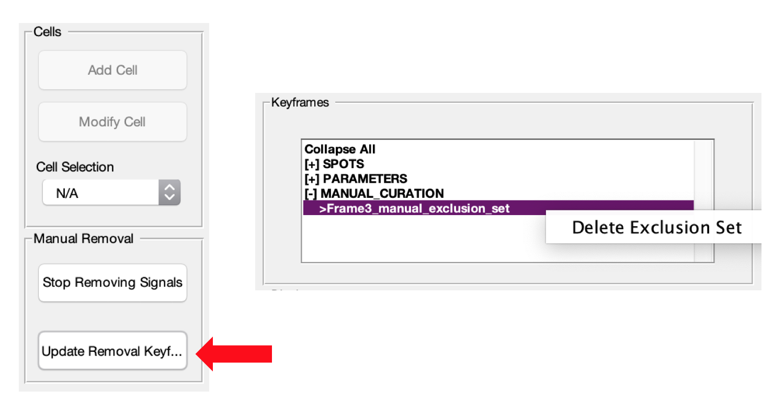

12. The Inspector Tool

The Inspector Tool allows for closer examination of the spots at a pixel-wide level. Once a keyframe for spot detection has been created, clicking on the image axis will highlight the nearest object. Right clicking the image axis after a spot has been highlighted in yellow will open a menu selection for the inspector tool.

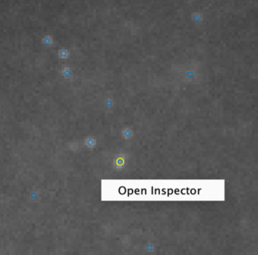

The inspector tool has several graphs and axes for examining detected objects’ pixels in detail. The components of the inspector tool are as follows:

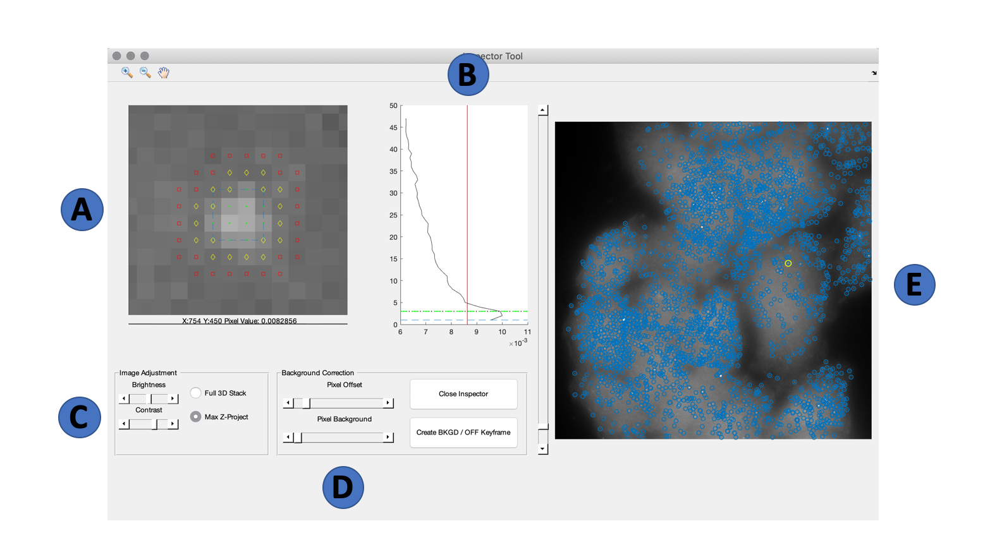

1. **Pixel Axis:** interactive axis which shows the currently selected object. The pixels comprising the actual object are in green, the region defined as offset for the object is identified by the yellow diamond marker, and the region being considered as background for that object is marked in red. Shifting sliders in the ‘Background Correction’ panel will update these marker regions accordingly. Hovering over the axis with a mouse will display a small bar at the bottom of the cropped image which will denote pixel coordinates and the value of the pixel currently below the mouse pointer. A small blue box will also appear denoting the minimum bounding box for the entire spot (including all z-slices), and the average pixel value of this bounding box throughout the entire 3D stack is displayed in the Zed Axis as the black curve.
2. **Zed Axis:** axis showing average pixel intensity taken throughout the entire z-stack for the bounding box of the currently displayed object. The bounding box for the current spot can be seen by hovering over the Pixel Axis. The red line represents the mean background value determined by the currently identified background region. The blue dashed lines indicate the axial bounds of the currently selected object. The green dashed line indicates that object’s centroid. The dotted black line indicates the currently displayed z-slice.
3. **Image Adjustment Panel:** panel containing image adjustment controls. The brightness and contrast sliders work in the same manner as the main dNEMO interface, and the toggles ‘Full 3D Stack’ and ‘Max Z-project’ alternate between the full 3D stack and maximum intensity z-projection for the image axis, respectively.
4. **Background Correction Panel:** panel containing components which update the number of pixels to be considered for the offset and background values on a per-spot basis. The ‘Pixel Offset’ slider and the ‘Pixel Background’ slider each adjust the radius for pixels to be defined as either ‘offset’ or ‘background’ relative to individual spots. Changing the values of these sliders will see those changes reflected in both the ‘Pixel Axis’ and the ‘Zed Axis’. Clicking on the ‘Close Inspector’ button will close the inspector tool and return to the dNEMO interface without assigning a new keyframe. Clicking on the ‘Create BKGD / OFF Keyframe’ button will apply the offset and background parameters from the current frame onwards, until a previously assigned offset and/or background parameter is found.
5. **Image Axis:** axis containing copy of the image currently being displayed in the main dNEMO interface. Clicking on the axis/objects within the axis will change the currently selected spot and update both the ‘Pixel Axis’ and ‘Zed Axis’ accordingly.

13. Output Files

To save dNEMO results, navigate to File > Save. A prompt will appear asking where to store the created results files. Once a filename and save location have been selected, dNEMO will create a new folder with the same filename containing several files.

The first of these files is a ‘full_results’ mat-file. This file contains all of the necessary data / structures to reload keyframes, cells, and removals back into the dNEMO application. However, this file is not in a reader-friendly format, so additional files with more structure are simultaneously created.

The first of these files is ‘<filename>_ALL_SPOTS.mat’, a mat-file containing both the keyframe detection settings for any created keyframes and all the detected spots’ features. The list of features detected per spot is indicated in the table below.

|  |  |
| --- | --- |
| **Frame** | Frame number |
| **XCoord** | Centroid x-coordinate |
| **YCoord** | Centroid y-coordinate |
| **ZCoord** | Centroid z-coordinate |
| **INT_AVG** | Mean spot intensity, background corrected |
| **INT_MED** | Median spot intensity, background corrected |
| **INT_SUM** | Integrated spot intensity, background corrected |
| **INT_MAX** | Maximum spot intensity, background corrected |
| **SIZE** | Spot size (number of pixels) |
| **INT_AVG_RAW** | Raw mean spot intensity |
| **INT_MAX_RAW** | Raw maximum spot intensity |
| **INT_SUM_RAW** | Raw integrated spot intensity |
| **BG_MEAN** | Mean intensity of background pixels associated with spot |
| **BG_STD** | Standard deviation of intensities of background pixels associated with spot |
| **BG_MAX** | Maximum intensity of background pixels associated with spot |
| **BG_SUM** | Integrated intensity of background pixels associated with spot |
| **BG_SIZE** | Size of background region associated with spot (number of pixels) |

The second of these files is ‘<filename>_ALL_CELLS.mat’, a mat-file containing cell polygon information, spot features associated with individual cells, and average trajectories of those properties over time. The properties selected for are identical to those properties stored in the ‘<filename>_ALL_SPOTS.mat’ mat-file, just associated to their individual cell.

The third of these files is an optional AVI of the segmented cells and detected spots. A prompt will appear asking the user for positive affirmation before creating this file.

14. Reloading Results into dNEMO

The only file necessary for recaputlating saved results in dNEMO is the ‘<filename>_full_results.mat’ mat-file. Open dNEMO in MATLAB and load in an image which has previously been analyzed/processed and thus has a ‘<filename>_full_results.mat’ mat-file. After the image has been loaded into dNEMO, navigate to File > Reload Results. There will be a prompt asking for a mat-file with the ‘full_results.mat’ within the filename to load into dNEMO. Navigate to where the previously created ‘full_results.mat’ mat-file was saved and select it to reload the previous results into the dNEMO application.

15. Guided Example: smFISH

This section provides a walkthrough for how to process a sample smFISH image through dNEMO. The sample image ‘SMFISH_SAMPLE.tif’ can be downloaded at the following location:

<https://pitt.box.com/s/huzv0bq4ksbm4q5asfyj8v976jpwwo1g>

This sample image is of the dimensions 1024 x 1024 x 47 and contains smFISH data.

1. To start, open dNEMO from the command window by typing the following:

>>> RUN_ME

1. When the application opens, navigate to File > Load Images. A prompt will appear asking for an image file. Navigate to the location where ‘SMFISH_SAMPLE.tif’ is stored and select it to open the image in dNEMO. This sample image is 3D, so when prompted for the dimensionality select ‘3D’ and click okay to confirm 47 z-slices.
2. Adjust the brightness and contrast as needed in the ‘Display’ panel, and navigate to the 3D Display > Full 3D Stack to examine individual slices within the 3D image. Use the slider that appears to the right of the image axis to move up and down the z-stack. Then select 3D Display > Max Z Project to return the image to a maximum intensity projection.
3. It is generally advised to create a keyframe detecting spots before segmenting individual cells. At the upper righthand corner of the ‘Spot Filter’ panel, click on either ‘Test Detect (Fast)’ to detect spots without performing the oversegmentation check for detected objects or ‘Test Detect (Full) to detect spots while performing the additional oversegmentation check. Adjust the wavelet threshold as needed in the upper left corner, and click either ‘Test Detect’ button to examine the effects of the updated threshold.
4. Use the histogram axis present within the ‘Spot Filter’ panel to examine the distribution of identified spots’ features. Select different properties with the feature dropdown box below the histogram. Once content with the wavelet threshold and some feature minimum and maximum, click the ‘Create Keyframe’ button. If the threshold hasn’t been adjusted since you clicked either of the ‘Test Detect’ buttons, dNEMO does not need to run the detection and the keyframe will automatically be saved, as the smFISH image is a single frame. Otherwise, the detection will run and save the detected objects & accompanying parameters as keyframes. You can examine these parameters in the ‘Keyframes’ panel.
5. Click the ‘Add Cell’ button in the ‘Cells’ panel to begin segmenting cells. Hovering over the image axis will change the pointer to a black crosshair, and clicking on the image axis will add points of a polygon to be considered as a new cell. Trace along the outline of a single cell and either reconnect the points with the initial vertex or double click to complete the polygon.
6. Once a cell is created, it can be further modified by selecting the cell from the dropdown menu in the ‘Cells’ panel or right-clicking on the cell in the keyframing map within the ‘Keyframes’ panel and clicking ‘Modify Cell’. To add additional points along the polygon, hold down A and click on the polygon’s edges. Once satisfied with the polygon you can click ‘Finish Cell Modify’ in the ‘Cells’ panel, or ‘Cancel Cell Modify’ in the ‘Cells’ panel if you were fine with the cell as it was originally drawn.
7. After a cell is created, the trajectory axis in the lower right-hand corner of the dNEMO interface should display a bar plot of the spots per drawn cell (bar plot for single images, trajectories for time-lapse images). Repeating the cell segmentation process will add additional bars to this axis.
8. Create several more single-cell measurements by repeating the cell segmentation process.
9. Once content with the drawn cells, save the results by navigating to File > Save. The prompt will ask for a location to save the mat-files. dNEMO will dreate a new folder with the same name containing three results mat-files. After those files are output, an additional prompt will inquire about producing an AVI of the cells quantified, which can be useful for time-lapse images.

16. Guided Example: EGFP-NEMO

This section provides a walkthrough for how to process a sample EGFP-NEMO image through dNEMO. The sample image ‘EGFP_NEMO_SAMPLE.tif’ can be downloaded at the following location:

<https://pitt.box.com/s/huzv0bq4ksbm4q5asfyj8v976jpwwo1g>

This sample time-series is of the dimensions 740 x 840 x 180 and contains 3D images of EGFP-NEMO in 3 U2OS cells in response to 100 ng/mL IL-1.

1. To start, open dNEMO from the command window by typing the following:

>>> RUN_ME

1. When the application opens, navigate to File > Load Images. A prompt will appear asking for an image file. Navigate to the location where ‘EGFP_NEMO_SAMPLE.tif’ is stored and select it to open the image in dNEMO. This sample image is 3D, so when prompted for the dimensionality select ‘3D’ and click okay to confirm 9 z-slices.
2. Adjust the brightness and contrast as needed in the ‘Display’ panel, and navigate to the 3D Display > Full 3D Stack to examine individual slices within the 3D image. Use the slider that appears to the right of the image axis to move up and down the z-stack. Then select 3D Display > Max Z Project to return the image to a maximum intensity projection.
3. Shift the movie forward using the slider beneath the image axis to a later time point which has the NEMO localizing to fluorescing puncta in the cells.
4. It is generally advised to create a keyframe detecting spots before segmenting individual cells. At the upper righthand corner of the ‘Spot Filter’ panel, click on either ‘Test Detect (Fast)’ to detect spots without performing the oversegmentation check for detected objects or ‘Test Detect (Full) to detect spots while performing the additional oversegmentation check. Adjust the wavelet threshold as needed in the upper left corner, and click either ‘Test Detect’ button to examine the effects of the updated threshold.
5. Use the histogram axis present within the ‘Spot Filter’ panel to examine the distribution of identified spots’ features. Select different properties with the feature dropdown box below the histogram. Once content with the wavelet threshold and some feature minimum and maximum, click the ‘Create Keyframe’ button. The settings will now be applied to every frame of the movie. Once the process is complete you can examine these parameters in the ‘Keyframes’ panel.
6. Click the ‘Add Cell’ button in the ‘Cells’ panel to begin segmenting cells. Hovering over the image axis will change the pointer to a black crosshair, and clicking on the image axis will add points of a polygon to be considered as a new cell. Trace along the outline of a single cell and either reconnect the points with the initial vertex or double click to complete the polygon.
7. Once a cell is created, it can be further modified by selecting the cell from the dropdown menu in the ‘Cells’ panel or right-clicking on the cell in the keyframing map within the ‘Keyframes’ panel and clicking ‘Modify Cell’. To add additional points along the polygon, hold down A and click on the polygon’s edges. Once satisfied with the polygon you can click ‘Finish Cell Modify’ in the ‘Cells’ panel, or ‘Cancel Cell Modify’ in the ‘Cells’ panel if you were fine with the cell as it was originally drawn.
8. After a cell is created, the trajectory axis in the lower right-hand corner of the dNEMO interface should display a plot of the spots per drawn cell (bar plot for single images, trajectories for time-lapse images). Repeating the cell segmentation process will add additional bars/trajectories to this axis.
9. Create several more single-cell measurements by repeating the cell segmentation process.
10. Return to the beginning of the time-series using the slider below the image axis. Larger objects which are not NEMO-punctate structures can be removed using the manual exclusion tool. Click the ‘Remove Signals’ button in the ‘Manual Removal’ panel. Either click on the spots detected which can be removed or click and drag to create a square region which identifies which spots to remove. Click on the ‘Update Removal Keyframe’ button in the ‘Manual Removal’ panel to save the removed spots before moving onto another frame. Move through the movie and remove any detected objects that should be excluded from analysis. Click on ‘Stop Removing Signals’ in the ‘Manual Removal’ panel to terminate the manual exclusion process.
11. Once content with the drawn cells, save the results by navigating to File > Save. The prompt will ask for a location to save the mat-files. dNEMO will dreate a new folder with the same name containing three results mat-files. After those files are output, an additional prompt will inquire about producing an AVI of the cells quantified, which can be useful for time-lapse images.

17. References

1. Linkert, M., C. T. Rueden, C. Allan, J.-M. Burel, W. Moore, A. Patterson, B. Loranger, J. Moore, C. Neves, D. MacDonald, A. Tarkowska, C. Sticco, E. Hill, M. Rossner, K. W. Eliceiri, and J. R. Swedlow. 2010. Metadata matters: access to image data in the real world. The Journal of Cell Biology 189(5):777.